To be able to load your application from Android Studio onto the WearOS device wirelessly, you need to follow these instructions.
- Make sure your laptop and WearOS device are on the SAME wireless network.
  - You CANNOT use the MSOE Guest network or secure network due to security restrictions
  - In DH 445 there is a special wireless network setup that should be used when in class
    - SSID: LabNet-SE
    - Pw: 999999999Nine
  - You can also use a personal router when at home that allows devices to communicate across the WiFi network
- Determine the IP address of the WearOS device
  - Make sure developer options is enabled on the device by going to Settings > About watch/device > Software info, then tap the Build number seven times until a message confirms you are now a developer
  - Next, make sure some developer options are enabled by going to Settings > Developer Options and enabling ADB debugging and Debug over Wi-Fi
  - Next, enable wireless debugging by going to Settings > Developer Options > Wireless debugging and enabling the Wireless debugging option if it isn’t already. Scroll down in that menu and copy down the IP address & port number which might look similar to: 10.199.252.155:55555
- CONFIRMATION STEP: You should open a terminal shell and confirm the devices can communicate by issuing the following command, where xxx.xxx.xxx.xxx is the IP address of the device
  - ping xxx.xxx.xxx.xxx
- In Android Studio, go to the device selector at the top and choose the Pair Devices Using Wi-Fi option.
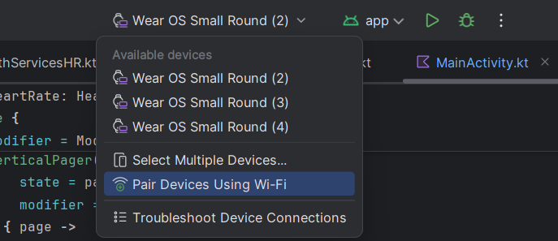
  - In the subsequent window, choose the “Pair using pairing code” tab.
    - If you don’t see your device listed, then double-check previous steps
  - On the WearOS device, go to Settings > Developer options > Wireless debugging > pair device with pairing code
    - Your device should show up in Android Studio now
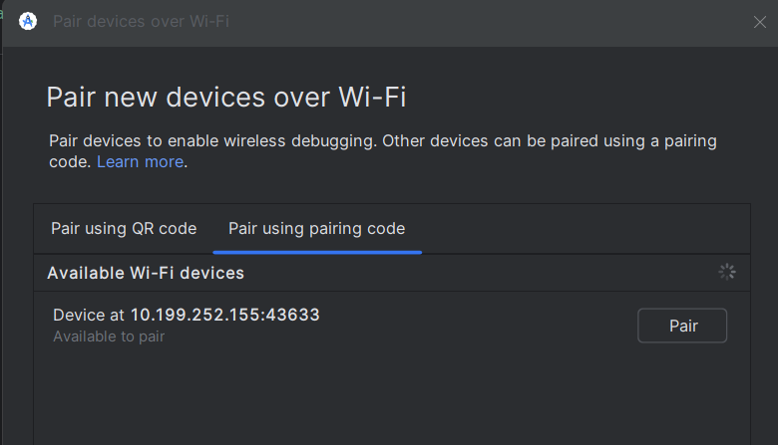
    - Make sure the IP address of your device and the device you select to pair with are the same.
    - Select “Pair”
    - Enter the 6 digit code shown on the screen of the WearOS device and select “Pair”
  - The device should now be shown in the device selector at the top
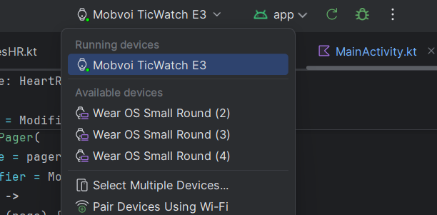
  - You can run your builds from Android Studio on this device now as long as the connection is maintained.

