CS498 Midterm Exam Name:
You may use an 8.5x11 note-sheet, printed on both sides. Review all questions before you get started. Write your initials on the front of each page (except this one). Show all work.

- (2 points) An original image has a histogram that looks like:
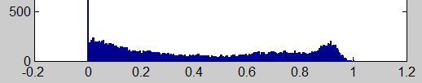
After modification, the image’s histogram looks like:
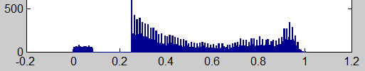
Circle one. Compared to the original, the modified image appears…
  - Darker, but with a light patch added
  - Darker, but with a dark patch added
  - Lighter, but with a light patch added
  - Lighter, but with a dark patch added
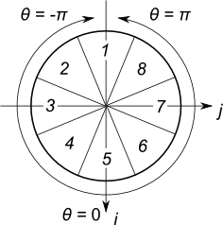
- (2 points) An edge histogram is created using the bins illustrated by the circular figure on the right. (A pixel falls into a bin if the image intensity increases in the direction of the bin’s wedge.) The resulting histogram looks like:
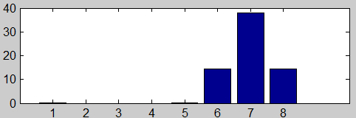
Select the image that was used to create this histogram:

- (6 points) Describe what will be wrong with output of a blurring filter that does not sum to one
- (15 points) Write a few lines of code to compute a blurred version I2 of an image I. The blur should be in multiple dimensions, but does not need to be Gaussian. The best solutions will not use loops and run quickly.

- (5 points) Explain why all the colors we can see can be represented with just three numbers.
- (5 points) Write the (R, G, B) value needed to produce the color yellow in an 8-bit unsigned image (i.e., using uint8, not double for each value)
- (8 points) Compute the matrix product $\left[\begin{matrix}1 \\ 1 \\ 1\end{matrix}\right]\left[\begin{matrix}2 & 1 & 3\end{matrix}\right]$
- (7 points) Write Matlab code to find a solution h to the equation Ph = r, where P is a 3x3 matrix, and r is a column vector. You may use inv(…) if you wish.

- (5 points) Considering this transformation: $\left[\begin{matrix}x_{2} \\ y_{2}\end{matrix}\right]=\left[\begin{matrix}? & ? \\ ? & ?\end{matrix}\right]\left[\begin{matrix}x \\ y\end{matrix}\right]$ , rewrite the square matrix below, filling in the question-marks. When any point [x; y] is rotated 90 degrees counter-clockwise around the origin, it will come to point [x2; y2].

- (5 points) Consider this transformation: $\left[\begin{matrix}x_{2} \\ y_{2}\end{matrix}\right]=\left[\begin{matrix}? & ? \\ ? & ?\end{matrix}\right]\left[\begin{matrix}x \\ y\end{matrix}\right]$ , rewrite the square matrix below, filling in the question-marks. The image is scaled down by a factor of two; that is, when any point [x; y] moves half-way to the origin, it will come to point [x2; y2].
- (10 points) Apply the full projective homographic transform to the homographic point. You do not need to convert the result back to a “real” point.
$$\left[\begin{matrix}1 & -1 & 40 \\ 1 & 1 & 7 \\ 0.01 & 0.01 & 1\end{matrix}\right]\left[\begin{matrix}10 \\ 20 \\ 1\end{matrix}\right]=$$

- (5 points) Suppose after applying a homographic transformation, you find a homogeneous point $[\tilde{i};\tilde{j};\tilde{w}]$ = [40; 30; 2]. Write the “true” point in the image, [i; j].

- (15 points) Considering that the matrix $\left[\begin{matrix}4 & 2 \\ 2 & 4\end{matrix}\right]$ satisfies $\left[\begin{matrix}4 & 2 \\ 2 & 4\end{matrix}\right]\left[\begin{matrix}1 \\ -1\end{matrix}\right]=2\left[\begin{matrix}1 \\ -1\end{matrix}\right]$ and $\left[\begin{matrix}4 & 2 \\ 2 & 4\end{matrix}\right]\left[\begin{matrix}1 \\ 1\end{matrix}\right]=6\left[\begin{matrix}1 \\ 1\end{matrix}\right]$ , find any value for $\left[\begin{matrix}x_{1} \\ x_{2}\end{matrix}\right]$that satisfies $\left[x_{1},x_{2}\right]\left[\begin{matrix}4 & 2 \\ 2 & 4\end{matrix}\right]\left[\begin{matrix}x_{1} \\ x_{2}\end{matrix}\right]=1$.

- (5 points) Explain why computing tr²(H)/det(H) < 10 is preferable to computing λ₁ > 10 λ₂.

- (5 points) Consider the following algorithm to rotate and scale up an image:
For each point p₁ in the original image:
Rotate and scale up p₁ to find a point p₂ in the destination image
Set the pixel at p₂ in the destination image to have the color
of the pixel p₁ in the original image.

Describe the undesirable artifact that this algorithm will produce in the destination image.

