Importing Code into EA
To quickly create an EA diagram: Dr. Yoder W2013-14
Start by creating an empty class diagram as we’ve done before. Your project browser should look like this:
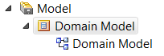
Right-click on the middle and select “Code Engineering…” Import source directory.
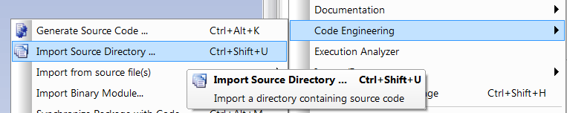
Select the Root Directory to be the folder containing your code. Make sure the source type is Java, and then hit OK. Just in case some of the other options are important, here’s a screenshot of mine:
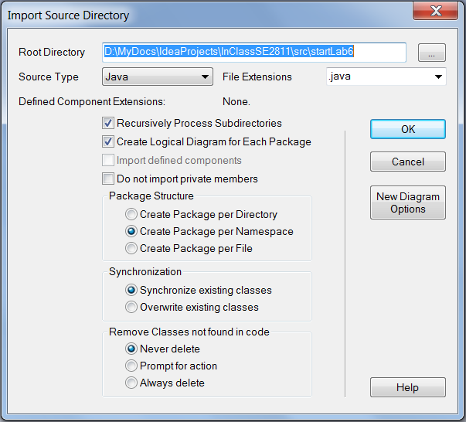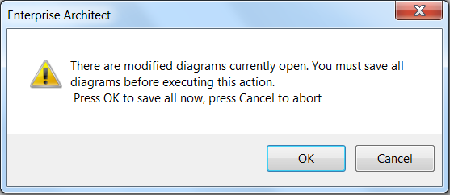
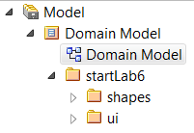
You might the warning above on the right. Probably best to say “OK to save all now.” You will see many diagrams pop up on your screen, but when it is done, the class diagram will still be blank. However, on the left you will see the Project Browser has changed:
Go into one of the folders and click on the class diagram symbol in there:
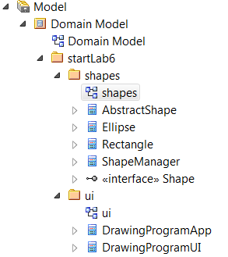
And you should see a rough class diagram, ready for a little tweaking:
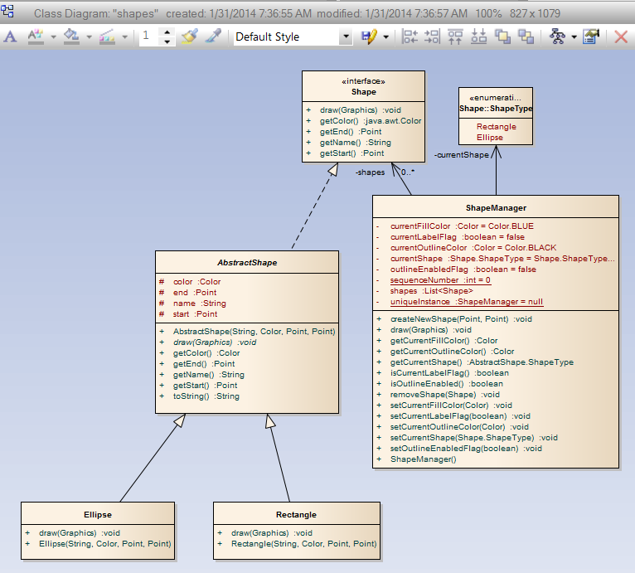
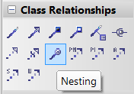
One thing you often need to add is the “inner class” symbol, called “nesting” in IntelliJ.

