SE2811 Quiz 3 Name:
- (2 pt.) List one or two problems that a Factory helps solve:
- (2 pt.) Give an example of how code reuse increases maintainability:

- (1 pt.) If a Duck class separates its swimming behavior and its display code into distinct behavior classes, it is illustrating
  - Low Cohesion
  - High Cohesion
  - Low Coupling
  - High Coupling
- (1 pt.) If the Mallard and Redhead duck classes both implement similar quacking algorithms they are illustrating
  - Low Cohesion
  - High Cohesion
  - Low Coupling
  - High Coupling
- (2 pt.) The class diagram below is an example of the ___________ pattern
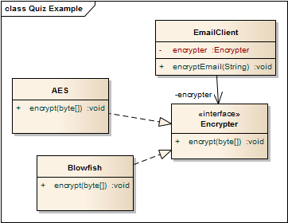
- (2 pt.) Select all that apply. An instance variable in a class A declared as protected int x; can be accessed from
- A class derived from A in the same package
- A class not derived from A in the same package
- A class derived from A in a different package
- A class not derived from A in a different package

