SE2811: Adapter Exercise
- Update the UML diagram as you would to apply the Adapter pattern and allow the Better Lamp to be used in the place of the Lamp.

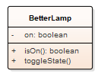

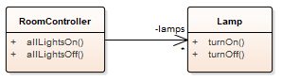

- Write the turnOn() method of the adapter class

