SE3910 Half-Exam 1 Name:

This is a closed-book, closed-computer, etc. quiz. Review all questions before you get started. ***Show all work. Box your final answer.*** The exam is printed double-sided.

1. (10 points) Consider a cookie factory with the following recipe
   1. Preheat oven to 400 degrees F
   2. Mix ingredients
   3. Lay out on cookie sheet
   4. Bake at 400 for 15 minutes

Once the oven is up to temp, the factory repeats steps b-d several times a day. Consider the deadline of removing cookies from the oven. **Circle one**: This is

1. a soft real-time constraint
2. a firm real-time constraint
3. a hard real-time constraint

***Explain*** your choice.

1. (10 points) A microcontroller and a microprocessor both contain a CPU. ***Name at least one*** thing found in a microcontroller that distinguishes the two.
2. (10 points) ***Describe*** the difference between synchronous and asynchronous events.
3. (20 points) For each case below, ***find*** the **voltage** across the GPIO pin and the **current** through it. If the voltage or current is undefined, ***explain*** what this means physically.  
   1. 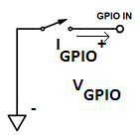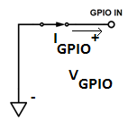S1 is closed (as pictured)
   2. S1 is open (as pictured)
4. (15 points) ***Determine*** the size of an uncompressed 640x480 RGB video frame in **Bytes** with an appropriate **binary multiplier**. As on all problems, show your work and box your final answer.
5. (15 points) Suppose you have video with 2,764,800 Byte frames at 59.94 frames per second. ***Determine*** the data rate in **bits/second** with an appropriate **binary multiplier**.

1. ***Fill in blanks*** for the voltage across and current through each component in the circuits below. Use an appropriate ***SI multiplier***. Each voltage has a + and – marking the difference measured.
   1. 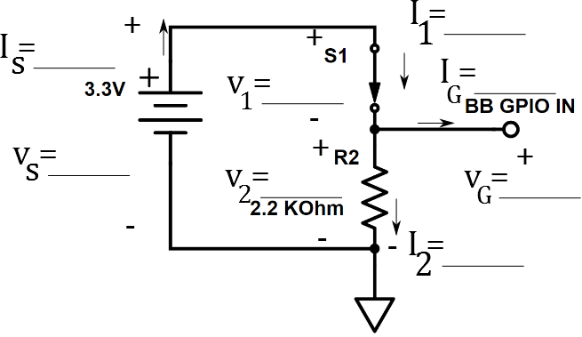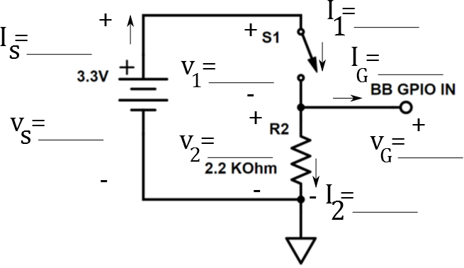 (10 points)
   2. (10 points)