SE3910 Half-Exam 2 Name:

This is a closed-book, closed-computer, etc. quiz. Review all questions before you get started. ***Show all work. Box your final answer.*** Use appropriate multipliers. The exam is printed double-sided.

1. (4 points) ***Select one***.
   1. The user pressing a GPIO pin is a …
      1. … synchronous event
      2. … asynchronous event
   2. Sending a sample of audio to a speaker (as part of playing a song) is a …
      1. … synchronous event
      2. … asynchronous event
2. (6 points) ***Circle*** the letter by ***all*** that are ***true***
   1. Software engineering affects the design of hard real-time systems.
   2. A hard real-time system is one that responds quickly to its input.
   3. A hard real-time system must meet its deadlines.
   4. Real-time systems are designed primarily with scheduling theory.
   5. A system is a mapping of a set of inputs into a set of outputs.
   6. To supply a result early is better than to supply the result on time.
3. 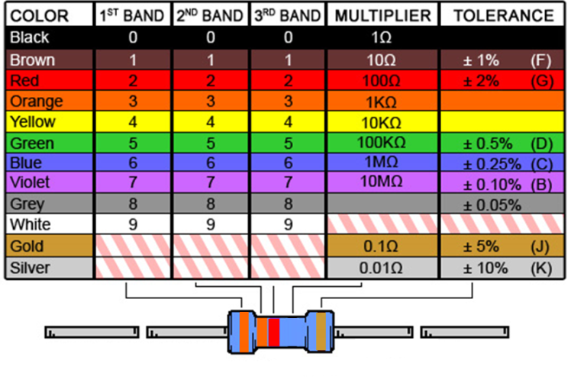Consider the resistor chart and the resistor with colored bands GREEE BLUE BROWN GOLD
   1. (4 points) ***Write*** the value of this resistor, including units and tolerance.
   2. (4 points) ***Write*** the current through the resistor if it is connected from a GPIO pin configured as output to ground.
   3. (2 points) ***Circle one:*** In the same configuration, 6.6 mA **is** / **is not** within the limits of the GPIO pin. (Sourcing limit: 4mA, Sinking limit: 8mA.)
4. (10 points) ***Name*** the design pattern implemented by signals and slots in Qt and ***describe*** what role (e.g. what class, method-call, etc.) the emit keyword plays in that pattern.
5. (15 points) My laptop has a 2.6 GHz (SI) clock. ***Determine*** how far a signal can travel on a wire if it travels 60% of the speed of light (c=299,792,458 m/s).
6. (15 points)Audio Signals. ***Determine*** the bitrate (in **bits/second**) necessary to send an uncompressed signal with a maximum audio frequency of 44 KHz (SI). Assume that each sample can have one of 2048 values (take this part slowly!). ***Use*** an appropriate **binary** multiplier.
7. (15 points) Channel Capacity. ***Determine***, in **bits/second**, the maximum theoretical bit-rate that can be sent through an analog channel with a bandwidth of 5 MHz (SI) and a signal-to-noise ratio of 60 dB. ***Use*** an appropriate **binary** multiplier. $B=H\log_{2}{(1+S/N)}$

1. ***Fill in blanks*** for the voltage across and current through each component in the circuits below. If a value is undefined, write a word to describe what is happening physically. Use an appropriate **SI** multiplier. Each voltage has a + and – marking the difference measured.
   1. 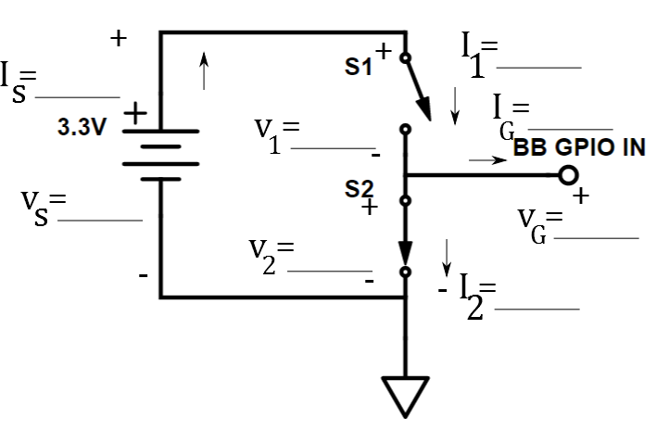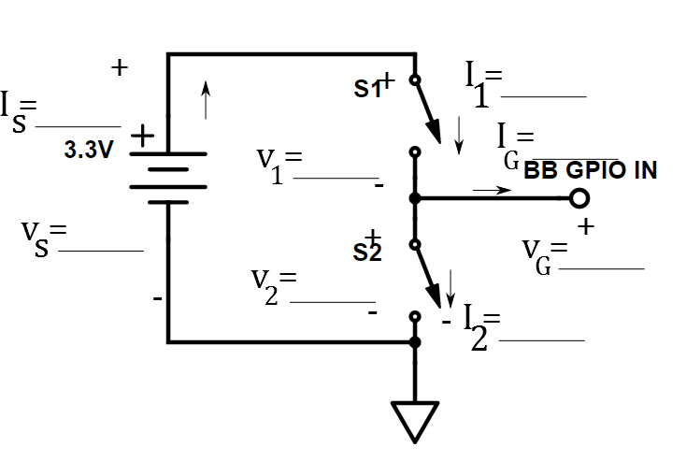(10 points)
2. (10 points)