SE3910 Quiz 1 Name:

This is a closed-book, closed-computer, etc. quiz. Review all questions before you get started. ***Show all work. Box your final answer.***

1. (10 points) Consider the circuit shown below. The voltage drop across the LED is 2.0 V, regardless of the current through it. ***Fill in*** all the blanks.

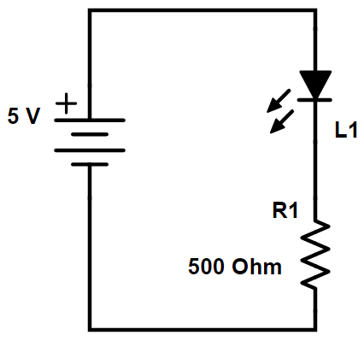

V

V

V

+

-

+

-

+

-

mA

mA

mA

1. (10 points) Consider the circuit shown below. ***Fill in*** all the blanks.

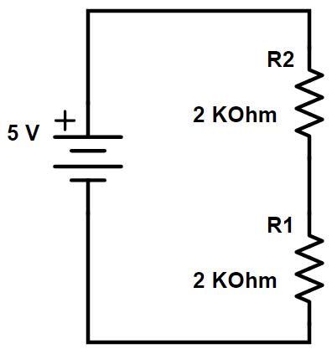

V

V

V

+

-

+

-

+

-

mA

mA

mA