SE3910 Quiz 2 Name:

This is a closed-book, closed-computer, etc. quiz. Review all questions before you get started. ***Show all work. Box your final answer.***

1. (6 points) ***Circle one*** ***and explain***. A student doing homework is an example of a  
     
    **hard**, **medium**, or **soft** real-time system.

System requirements: Pass the class. Explain:

1. (4 points) ***Write***, as a percentage (e.g. 75%), the duty cycle of the signal below:

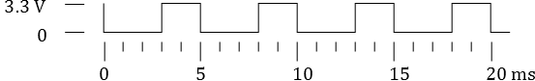

1. (4 points) ***Define*** latency in your own words.
2. (6 points) For the circuit below, ***explain*** what happens (e.g., what is the voltage at the BeagleBone GPIO? What is the current through the wire?) when
   1. 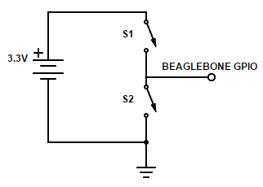Both S1 and S2 are open (as pictured)
   2. Both S1 and S2 are closed