SE3910 Quiz 3 Name:

This is a closed-book, closed-computer, etc. quiz. Review all questions before you get started. ***Show all work. Box your final answer.***

1. (5 points) Given a 100x100 image with 255-colors per channel, RGB, ***find*** the uncompressed size of the image, in **Bytes**. ***Include*** an appropriate SI-multiplier on your answer. ***Include*** units in your calculations and on your answer.

1. (5 points) ***Given*** the same image, and a frame rate of 10 frames/second, ***find*** the data rate in **bits/second**. ***Include*** an appropriate SI-multiplier on your answer. ***Include*** units in your calculations and on your answer.
2. (10 points) For each case below, ***find*** the **voltage** across the GPIO pin and the **current** through it. If the voltage or current is undefined, ***explain*** what this means physically.  
     
     
   1. 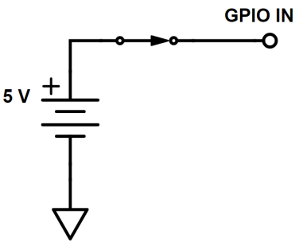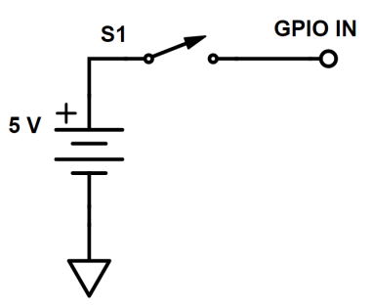S1 is open (as pictured)
   2. S1 is closed (as pictured)